Title of the scientific contribution
N. Participants¹, N. Author^{2,3}, N. Author³ and L. Author³
- Participant’s affiliation , Department, ZIP – City
- Affiliation, Department, ZIP – City
- Last affiliation, Department, ZIP – City
The abstract should be written in English and cannot exceed one page. For the title, use Character Type Times New Roman 16 in bold; authors’ name 10 and affiliation 9 pt. In the authors’ list the name of the presenting author should be underlined. Text should be full justified, 1.2 leading, Times New Roman 11. References should be numbered consecutively and placed in the text as superscript arabical numeral surrounded by square brackets.^{[1]}

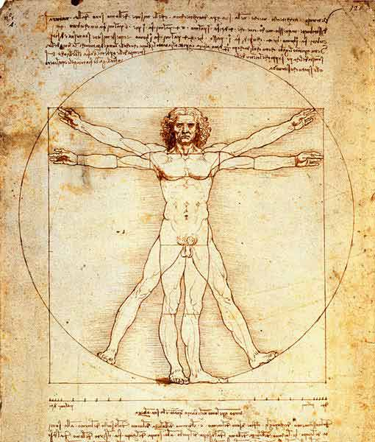
Figure 1. Figure caption example. Times New Roman 10 pt, bold.
The abstract may contain tables and or figures. Figures will be printed in gray scale. Please, do not cite the figures in the text, but use captions to the figures. Figures should be centred without surrounding text. The captions should be centred with character size 10 (in bold).
The best way to implement these rules is to write inside this document without using the “paste” function to cut and paste from another file. Please use the WORD function “paste special” to paste the text in unformatted way.

References
- P. Scott, V. Adels J. Appl. Crystallogr. (2007), 35, 24.
- P. Scott, V. Adels J. Appl. Crystallogr. (2007), 35, 24.

